BIO116; Zoology

Nematodes and Chemotaxis

Introduction

Caenorhabditis elegans is a small free living nematode that is found in the soil of the temperate regions around the world. It feeds on bacteria growing on rotting vegetation. Therefore, it is part of the detritus food chain and helps recycle nutrients in ecosystems. C. elegans is also an important research organism studied in hundreds of laboratories around the world. Research with C. elegans has led to major discoveries in animal behavior, development and cell biology.

Simple model organisms, like C. elegans, can be used to understand the biology of larger and more complex organisms. An example of this with C. elegans would be cancer in vertebrates. Cancerous tumors are generated by uncontrolled cell division. Cancer cells arise from normal cells that have suffered mutations in the genes that control cell division. Normal cells usually have the ability to detect uncontrolled division caused by these mutations. When they detect abnormal cell division they undergo a controlled cell suicide called apoptosis. This cell suicide protects the organism from cancer. Millions of cells within a human undergo apoptosis every day. Cancer only occurs when apoptosis fails. Anti-cancer treatments work by restoring apoptosis. Most of what we know about apoptosis we know from studies with the nematode C. elegans. These studies with C. elegans led to a Nobel Prize in Medicine for Drs. Sydney Brenner, Robert Horitz and John Sulston.

Another example of a trait of large organisms that can be studied in C. elegans is the olfactory sense (sense of smell). The nematode uses this sense to locate and move toward food. Understanding olfaction in worms, can help us understand similar processes in humans.

This two week laboratory exercise will use C. elegans. Specifically, you will examine the anatomy of C. elegans using a microscope. You will grow C. elegans on a Petri dish. Finally, you will investigate which compounds released by bacteria are detected by the nematode’s olfactory sense to locate its food.

Specific Goals

- Be able to describe the life cycle of C. elegans and identify eggs, larval and adult stages of the nematode.

- Be able to identify and describe the anatomical features of C. elegans using a light microscope.

- Be able to use morphological traits to distinguish male and hermaphrodite C. elegans.

- Be able to describe the characteristics of C. elegans that makes it an effective laboratory research organism.

- Be able to establish cultures of C. elegans using “worm picking” method.

- Be able to define chemotaxis and explain how it is an adaptive trait in C. elegans.

- Collect and analyze experimental results investigating which types of compounds released by bacteria are used by C. elegans for chemotaxis.

Anatomy

C. elegans has two sexes, hermaphrodites and males (Figure 1). The hermaphrodite produces both sperm and eggs. It can use these gametes for self-fertilization. The male produces only sperm. Therefore, there are two ways C. elegans can reproduce: self-fertilization in hermaphro-dites and hermaphrodite/male matings.

Hermaphrodite and male C. elegans differ morphologically and can be distinguished under the microscope. Hermaphrodites are larger than males, are filled with brown eggs and have a thin tapered tails. Males are thinner than hermaphro-dites and have a fan shaped tail that they use during mating. This male tail structure is called the copulatory bursa and consists of rays and copulatory spicules. Male C. elegans also display a characteristic mating behavior. When a male encounters a hermaphrodite, it will align its anterior end with the anterior end of the hermaphrodite. Then it will then move its copulatory bursa up and down the length of the hermaphrodite body to deliver sperm to the vulva.
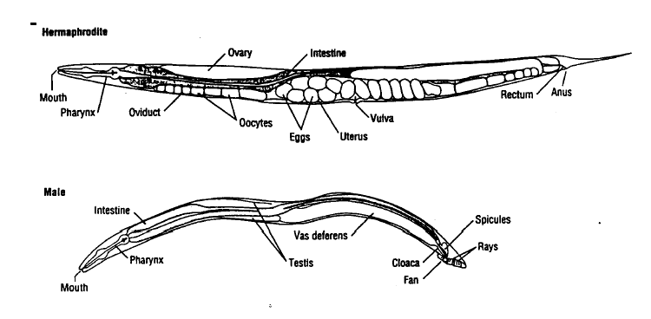
Figure 1: Anatomy of hermaphrodite and male C. elegans.
A mature C. elegans is approximately 1 mm long. Its structures are transparent under the microscope. The body plan of C. elegans essentially consists of two inner tubes within an outer tube. The outer tube is the exterior cuticle, hyperdermis and associated musculature and nerves. The two inner tubes are the digestive tract and the reproductive system. The digestive tract consists of the mouth, a bilobed pharynx that crushes bacteria, the intestine and the anus. The reproductive tract is the second internal tube. It is the largest structure in a hermaphrodite C. elegans. It consists of two lobed ovaries producing large oocytes, the uterus and vulva. In males, the reproductive structure is much smaller, consisting of a single testis releasing sperm into a long vas deferens and cloaca near the copulatory bursa.

Lifecycle

The lifecycle of C. elegans, like that of other nematodes, consist of six distinct stages: embryo, L1 stage larva, L2 stage larva, L3 stage larva, L4 stage larva and adult (Figure 2). At 25º the entire life cycle takes about 2 days.

Embryo: The first stage of the lifecycle is the embryonic stage. Embryogenesis begins when the oocyte is fertilized within the uterus and takes place entirely within the egg. The egg remains in the uterus for about 4.5 hours until it is laid. A larva hatches from the egg 14 hrs after fertilization.

Four Larva Stages: The larval stages of the nematode lifecycle can be divided into four distinct stages. These four larval stages are named L1 – L4. Each of the larval stages is separated by a molting of the exterior cuticle. The L1 larva hatches from the egg about 14 hours after fertilization. This stage last approximately 12 hours. The L1 molts to generate the L2 stage. The L2 stage last approximately 7 hours. The second molt generates the L3 larva. The L3 stage lasts about 8 hours. The third molt generates the L4 larva. The L4 stage lasts about 10 hours. The final molt generates the adult stage.

Adult Stage: An adult hermaphrodite starts fertilizing oocytes about two hours after the last molting. This results in a total generation time for C. elegans of approximately 51 hours. The adult worm can live approximately two to three weeks. A hermaphrodite can produce approximately 1000 oocytes, but only 250 spermatocytes. Therefore, unless it is fertilize by a male, the maximum number of offspring during its lifespan is 250.

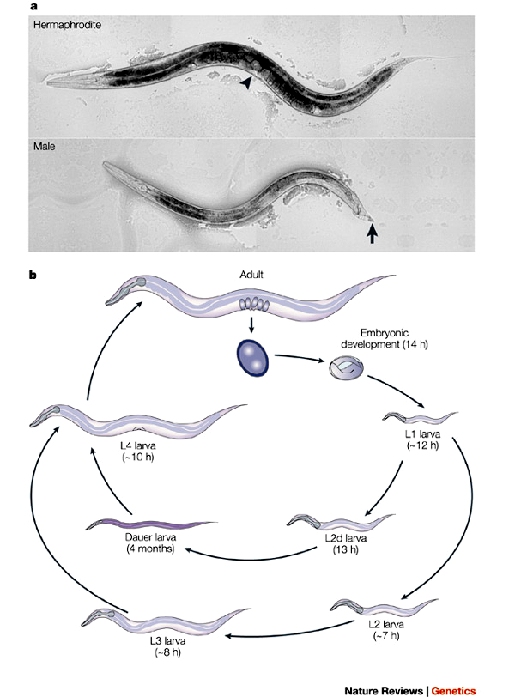
Dauer Stage: If the L2 stage larva is starved, it takes an alternative developmental pathway and develops into a stage called the dauer larva. This process does not require molting. The dauer larva can be distinguished from the other stages, because the dauer larva are unusually thin. The dauer larva can survive for up to 4 months without any food. This allows the nematode to survive adverse conditions. As soon as the dauer encounters food it molts and develops into an L4 larva.
Figure 2. Caenorhabditis elegans life cycle.

The length of the lifecyle is very temperature dependent. As described above, at 25º the life cycle takes about 2 days. At 20º it takes about 3
days and at 15º it takes 1 week. Long term exposure to temperatures lower than 15º or higher than 25º can be lethal to C. elegans

Model Organism

The choice of C. elegans as a model research organism can be credited to one person, Dr. Sydney Brenner. By the early 1960s, Dr. Brenner had already made major discoveries in molecular biology including the existence of mRNA and the triplet nature of the genetic code. After the major breakthroughs of that era, he concluded that the big problems in molecular biology had already been solved. Dr. Brenner deliberately changed his research to tackle what he believed would be the next big problems in biology, animal development and the nervous system.

He planned to employ the same type of genetics that had led to the major discoveries in molecular biology to investigate development and the nervous system. However, the research organisms that had worked in molecular biology, bacteria and viruses would be useless for studying animal development and the nervous system. He searched for a new research animal that had characteristics suitable for genetic analysis. He settled on the nematode C. elegans.

It has since become a favorite model organism for developmental biologist and neurobiologist. The characteristics that make C. elegans a good research organism include the following:

- Small size – the adult consist of only 959 cells, all of which are visible under the microscope.
- Easy to cultivate - can be grown at room temperature, and a single Petri dish can contain 10,000 nematodes.
- Easy to breed. Different strains can be crossed by mating males and hermaphrodites. A single hermaphrodite can produce 250 offspring.
- Numerous mutant strains are available from the nematode stock center.
- The entire genome has been sequenced and the sequence of all 19,000 genes is known.
- Techniques have been established for manipulating the genes of C. elegans.

Culturing C. elegans

C. elegans can be easily cultured on Petri plates containing a simple agar media called nematode growth media (NGM). The nematodes feed E. coli bacteria. These bacteria are seeded (or spread) on the surface a NGM plate. Thousands of worms can be grown on a single plate.

The easiest way to initiate a culture a technique called “chunking”. For chunking, a sterile wire is used to cut a 3 mm square of agar from an existing culture. This chunk may contain more than 100 nematodes. To start a culture, simply place the chunk on the surface of the fresh NGM plate that has been seeded with bacteria. The nematodes will move out of the chunk and onto the surface of the plate. This is a good way to rapidly begin a new culture

A new culture can also be established by introducing a single hermaphrodite to a new plate. Remember that a hermaphrodite can self fertilize its own eggs and can produce more that 200 offspring during its life span. Individuals worms can be “picked” from an established culture using a worm pick. A worm pick is essentially a thin wire probe. The probe is used to lift a single nematode from the surface of an established culture then deliver it to a freshly seeded plate. If a mature hermaphrodite is introduced to a plate, it will begin laying eggs almost immediately. When using a worm pick, care must be taken not to damage the nematode or to cut into the surface of the plate agar.

Care must also be taken to not introduce contaminating bacteria or fungi to the Petri dish while culturing the nematodes. Keep the Petri dish covered when not actively working with the nematodes. The worm pick can be sterilized in 70% alcohol and air dried.

Chemotaxis

Life in the soil, like life elsewhere, is associated with a number of problems that affect survival and reproduction. Not the least among these is finding food. C. elegans has the ability to locate and move toward its food. This behavior can most easily be seen on a Petri dish. If a drop of bacteria is spotted on one side of a Petri dish and a C. elegans is placed on the opposite side of the Petri dish, the nematodes will rapidly more toward the bacteria.

It is believed that C. elegans can detect and move towards the bacteria because it can detect volatile compounds released by the bacteria. Bacteria release a number of different volatile compounds when they grow on rotting vegetation. Anyone who as smelled rotting leaves can attest to this.

The ability to detect volatile compounds is the olfactory sense (sense of smell). C. elegans has a set of special olfactory neurons in the anterior end of the worm that can detect a variety of compounds.

The movement of C. elegans towards the chemicals released by the bacteria is an example of chemotaxis. Chemotaxis is defined as the movement of an organism toward or away from a chemical stimulus. Positive chemotaxis is movement towards a chemical, negative chemotaxis is movement away from a chemical.

Chemotaxis Assay

In this exercise you will investigate which of the chemical released by bacteria triggers the positive chemotaxis response. It is simple to assay chemicals for a chemotaxis response. A test arena is setup in agar Petri plate (Figure 3). At one end of the plate a small amount of the compound to be tested is spotted. At the opposite end, a control compound is spotted (usually water). Nematodes are placed in the center of the plate and allowed to move around for one hour. If they have a positive chemotaxis response to the test compound they will move from the center of the plate towards the test compound. If they have a negative chemotaxis response to a compound they will move away from the test spot and end up near the water spot.

To quantify the relative level of chemotaxis towards any compound, a chemotaxis index (CI) is calculated. To calculate the CI allow the worms to move on the plate for 30 min. After 30 minutes count the number of nematodes within 2 cm of the test compound, the number of nematodes within 2 cm of the control and the total number of nematodes on the plate. The CI is calculated as follows:

(# at test compound) – (# at control spot)
CI =
(total # of nematodes on the plate)

Test Compound
Control (Water)
Nematodes
A.
B.
C.
Figure 3. Chemotaxis Assay. Panel A is a diagram of the chemotaxis plate at the beginning of the assay. The location of the compound to be tested and the control water are represented by dots. The dashed circles represent the 2 cm zone around the compounds that are used to determine the chemotaxis index. At the beginning of the assay the nematodes are placed in the center of the plate. Panel B represents a positive chemotaxis response to the test chemical after 30 minutes. Panel C represents a negative chemotaxis response after 30 minutes.

Exercise

Week 1

Microscopy

- Obtain prepared slides of C. elegans. And examine slides under a light microscope.
  - Identify differences between male and hermaphrodite C. elegans.
  - Identify major components of digestive tract.
  - Identify major components of male and hermaphrodite reproductive system.
  - Identify characteristics that distinguish larval stages from adult stage.

- Obtain culture of C. elegans. Examine culture under dissecting microscope. Identify stages of lifecycle apparent in the culture.

(Draw nematode and label major structures?)

Culturing C. elegans

- Obtain 3 NGM plates that have already been seeded with E. coli.

- Find an adult hermaphrodite nematode under the dissecting microscope.

- Use the worm pick to transfer the adult nematode to a new NGM plate.

- Briefly dip the worm pick in 70% ethanol.
- Air dry worm pick by waving in the air for 30 seconds.
- Gently use the worm pick to lift the nematode.
- Transfer the nematode to the new NGM plate.
- Observe nematode under the scope to be sure you did not kill it.

- Place culture in 15º incubator for 1 week.

Week 2

Chemotaxis Assay

- Obtain a compound to test for a chemotaxis response. Different students in the class will test different compounds.

- Place a filter disk containing the test compound 2 cm from one end of the plate and a disk of water 2 cm from the other end of the plate. Keep the lid on the Petri dish, except when adding worms

- Remove C. elegans cultures from incubator and observe under microscope.

- Rinse worms off plate. Use plastic transfer pipette to add 2 ml of S buffer to surface of plate. Briefly swirl the buffer around the plate. Tilt the plate so that the water runs to one edge. Use the transfer pipette to transfer the worms to a small assay tube.

- Allow the worms to settle to the bottom of the tube for about 3 minutes. Use the transfer pipette to remove the water above the settle worms.

- Use the transfer pipette to transfer the remaining the settled nematodes to the center of the chemotaxis plate.

- Use the twisted end of kimwipe paper to draw off excess water off of the nematodes. Break up any clumps of nematodes by touch the clump with the tip of the twisted kimwipe.

- Allow the worms to move around the plate for 30 minutes.

- Count the total number of nematodes on the plate, the number of nematodes within 2 cm of the test compound and the number of nematodes within 2 cm of the water. Calculate the chemotaxis index for your compound.

- Compare your compounds chemotaxis index with the indices of other students in the class.

References
http://fire.biol.wwu.edu/trent/trent/Mendel.pd

Lab Report

1. Prepare a table reporting the chemotaxis indices for the three compounds tested in the experiment.

2. Based on the results summarized in your table, which compounds elicit a positive chemotaxis response.

2. Suppose that you have been commissioned to write a student laboratory manual on how to mate C. elegans. Write a paragraph explaining the easiest way to distinguish male and hermaphrodite C. elegans. Assume that the students who read your paragraph have never seen C. elegans. You may supplement your paragraph with drawings.

3. The third page of this lab handout lists the traits of C. elegans that makes it a good model research organisms. Which if any of those traits were important for the experiment performed in this exercise?

4. Based on your experience with this laboratory exercise, do humans have olfactory receptors that allow them to distinguish between the three compounds used in this exercise. Explain your answer.

5. Label the photographs below to show the location of the Anus, Mouth Pharynx, Ovaries, Uterus, Eggs, Intestine and Cuticle.



