Bus.313: Managerial Accounting
Dr. Ahiarah
ETO 6th, Chapter 5: Cost Management in an Automated Business Environment, ABC, ABM, and TQM
Quick Overview: What is ABC? On What Cost does it focus? Activity Based Costing (ABC) is a method of assigning indirect costs to cost objects. It first identifies and clusters activities required or consumed by cost objects, and the activities’ costs into activity pools/centers that share a common cost driver, and then using the drivers, assigns the costs to cost objects based on the cost objects’ relative consumption of the activities/cost drivers (see diagram below)
What is ABM? Where ABC focuses on determining how much activities cost, Activity Based Management (ABM) uses the ABC data and focuses on the management of the activities, to continuously improve the efficiency of the activities, to reduce cost and increase the effectiveness of the activities, thus providing quality service that improves stakeholder value. How does ABC work? Compare Traditional OH Cost Allocation approach and the ABC approach.
Introduction: Chapter 5 introduces activity based costing, a tool that has been embraced by a wide variety of service, manufacturing, and non-profit organizations to more accurately assign indirect costs to cost objects including products and services. The global business environment is increasingly competitive. Companies are using technology as never before to increase productivity and reduce costs. Management accountants are expected to accurately measure costs and thus facilitate their control. A number of companies have, traditionally, used a single plant-wide or departmental overhead (OH) rate and direct labor hours to allocate their OH costs. OH rates based on direct labor hours have been traditionally used in labor intensive processes. In these labor intensive processes, OH costs were relatively small, and the amounts allocated to products insignificant when compared with labor and material costs. In more modern, automated processes, however, OH costs are relatively large and labor costs are relatively small. Allocation of large amounts of OH based on direct labor in an automated process may result in unreliable product cost information at best and cost distortion at worst. ABC tries to trace OH more closely to the cost objects that create or cause the OH costs.
THE LOGIC OF ACTIVITY-BASED COSTING
Customers
or
Clients
Resources
Activities
or
Processes
Products
or
Services
Costs

which
demand/consume require/consume that consume and incur/cause
Setting up equipment Materials Cost
Mixing/drilling/Milling Material Indirect Costs
Inspecting, Packaging Labor Workers/Personnel Pay
Data entering/processing Tools/Utilities Power, tool costs
Moving materials License fees, Property Taxes
Designing products
Maintaining equipment
Purchasing Parts Ahiarah-2010
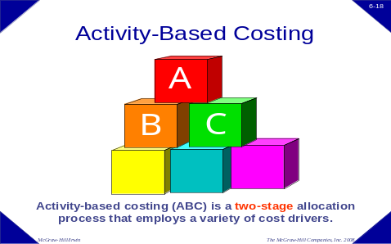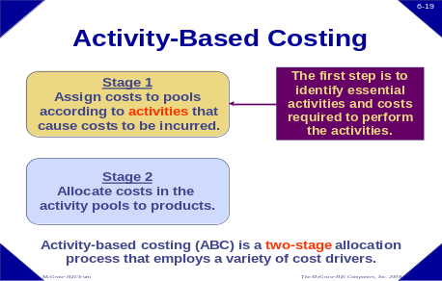
In the first stage, ABC tries to trace accumulated individual (first order) costs to activities/processes that consume/cause them; then, in a second stage, the accumulated costs of the activities/processes are traced to the appropriate destination cost objects (products/services, customers, channels…,) that use/consume/cause the activities, so that the costs can ultimately be recovered through pricing from the customers who consume/demand the products or services.
Carver Soup Company makes two types of canned soup, vegetable and tomato, in batches. The total volume of vegetable soup is 954,000 cans and the total volume of tomato soup is 234,000 cans. Each time Carver changes from a batch of one kind of soup to a batch of the other soup, it incurs batch setup costs. Carver plans to make 180 batches of each kind of soup in the period. Each batch setup costs $264 for a total of $95,040 of setup costs in the period.
If Carver allocates the batch setup costs to the two products based on the number of cans (a volume-based allocation rate), the overhead rate of 8 cents per can is found by dividing $95,040 by the 1,188,000 total cans of soup. Multiplying 8 cents per can times the number of cans for each product results in $76,320 of overhead costs allocated to vegetable soup, and $18,720 of overhead costs allocated to tomato soup. The volume-based allocation results in much more of the costs being allocated to vegetable soup ($76,320 versus $18,720) even though the cause of the $95,040 batch setup costs is the number of batches, not the number of cans produced. An activity-based allocation using the number of batch setups is more appropriate for the allocation of the $95,040 of batch setup costs. At $264 per batch setup, each product is allocated $47,520. Table #2 and #3, below show a comparison of the amounts allocated using the volume-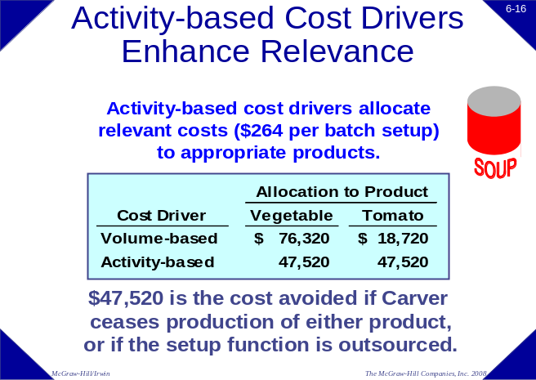based cost driver (number of cans) and the activity-based cost driver (number of batch setups). The activity-based cost driver allocates relevant costs to the product. For example if Carver is considering dropping tomato soup, which method of allocation reveals how much of the $95,040 of batch setup costs that would be saved? Since dropping tomato soup would eliminate 180 setups, Carver would save $47,520, the amount allocated using the activity-based cost driver.
Table #2 Table #3
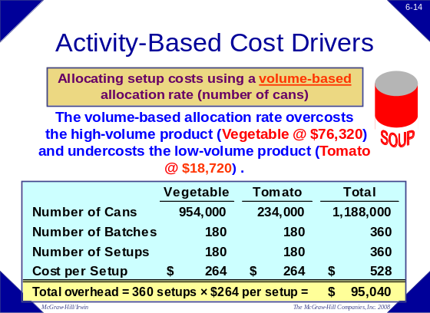 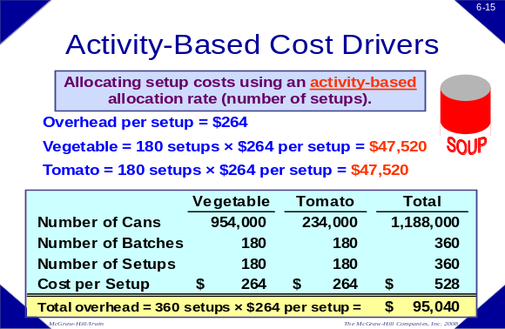
In an activity-based costing system, or ABC system, a company uses a number of allocation bases, such as the number of batch setups for Carver Soup Company, for assigning costs to products. Each allocation base represents a major activity that the company believes causes overhead costs to be incurred. An ABC system is designed to help more clearly determine the overhead costs we assign to each job or process. At the beginning of the design of an ABC system, we must first identify the activities that consume overhead resources. The first stage in the two-stage allocation process is to trace or assign overhead costs to those activities. Second, we allocate the costs from the activity cost pools to products using an activity rate based on the amount of the activity used by the product. The central idea is that products require activities in the manufacturing process, and that these activities consume overhead resources. When we use the traditional method of overhead assignment, the first step is to assign overhead costs to a cost pool such as an operating department. Once the overhead costs have been accumulated in the departmental cost pools, the second stage is to apply those costs to products as they are worked on in the departments. We begin the development of our ABC system by identifying activities that consume resources. Next, we assign the costs to a cost pool for each activity identified. Then we determine the association between the cost driver and the activity. Next we compute the overhead rate for each activity. This activity rate is calculated in the same way as a single predetermined overhead rate for a department. Finally, we assign overhead costs to products based on the actual level of activity. The first step is identifying and defining activities and activity cost pools. An activity cost pool is any part of the production process for which management would like to have separate reporting. Normally we refer to these as unit-level activities, batch-level activities, product-level activities, and facility-level activities (see chapter 5, pp208-212, of ETO 6th ed.)
Unit-level activities are performed each time a unit is produced. For example, providing power to run processing equipment would be a unit-level activity. Batch-level activities are performed each time a batch is handled or processed, regardless of how many units are in the batch. For example, setting up equipment and shipping customer orders are batch-level activities. Product-level activities relate to specific products and must be carried out regardless of how many batches are run or units produced and sold. For example, designing, advertising or maintaining a product would be product-level activities. Facility-level activities are carried out regardless of which products are produced, how many batches are run, or how many units are made. For example, heating a factory and cleaning executive offices are facility-level activities. Customer-level activities (not part of inventoriable/product cost)—sales calls, catalog mailings and general technical support.
ABC implementation may lead to cost-cutting measures that result in job losses. When adopting ABC systems that result in job losses, employee morale will be affected, not just the morale of employees whose jobs are discontinued, but also the morale of all employees who might be worried about their own jobs because of the downsizing. Under these conditions, employees are sometimes uncooperative with management efforts to adopt an ABC system. Uncooperative attitudes can affect the data collection and analysis necessary for successful ABC implementation. Obtaining employee support and accurate data are two of the more challenging obstacles to successfully implementing ABC.
The term quality has many meanings. Quality can mean that a product has many features not found in other products; it can mean that it is well-designed; or it can mean that it is defect-free. Our focus will be on the presence or absence of defects. Quality of conformance is the degree to which the actual product or service meets its design specifications. Anything that does not meet design specifications is a defect and is indicative of low quality of conformance. There are four broad categories of quality costs: prevention costs, appraisal costs, internal failure costs, and external failure costs. Prevention costs and appraisal costs are voluntary costs to control quality. Internal failure costs and external failure costs are costs to correct quality failures. Voluntary costs and failure costs move in opposite directions. Certainly we would like to reduce external failures and the resulting loss of customer goodwill, but at what cost? It's a balancing act. We know that if we spend more money on prevention and appraisal, we will reduce the number of defective units that lead to internal and external failures. The graph on p.216 of the text (ETO 6th) shows the cost of quality on the vertical axis and the level of quality on the horizontal axis. As we spend more money on prevention and appraisal, we should notice a decline in the internal and external failure costs. At the point where the line representing internal and external failure costs crosses the line representing prevention and appraisal costs, total cost of quality is minimized.
Quality cost reports. A quality cost report details the prevention, appraisal, internal failure, and external failure costs that arise from a company's current quality control efforts. When interpreting a cost of quality report managers should look for two trends. First, increases in prevention and appraisal costs should be more than offset by decreases in internal and external failure costs. Second, the total quality costs as a percent of sales should decrease. To effectively manage quality costs, we must know the amount of cost incurred for each cost of quality category.
On your screen, you see a management report indicating these costs. Note that the costs of internal and external failures are the largest cost categories. This is a significant issue that deserves management attention.
Part III: Please answer Part III (1 to 3) based on the following:
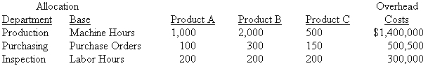
Part III (1) Which of the following bases would be an example of a traditional company-wide allocation base in a highly automated manufacturing environment? (a) Machine Hour; (b) Machine Hours and Labor Hours; (c) Machine Hours and Purchase Orders; (D) Machine Hours, Purchase Orders and Labor Hours.
Your answer:___________

Part III (2) If total overhead is allocated based on machine hours, how much overhead would be allocated to product A? Your answer:___________ Please show your answer and the computation(s) supporting it below:

Part III (3) Assume overhead is allocated using ABC, how much overhead would be allocated to product B? Your answer:___________ Please show your answer and the computation(s) supporting it below:

Please answer Part III (4 to 10) based on the following Lev's Clothing information:
Lev's Clothing has two product lines that it manufactures, Jeans and Shorts. Some summary manufacturing data are as follows:
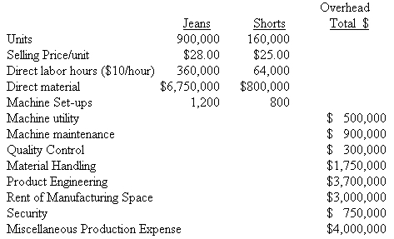
Part III (4) Which of the following is considered to be a direct cost?
 | A) | Machine maintenance
 | B) | Machine utilities
 | C) | Quality control
 | D) | Wages of production workers
Part III (5) Which of the following is considered to be a unit-level cost?
A) | Machine set-ups
B) | Machine maintenance
C) | Material handling
D) | Product engineering
Part III (6) Which of the following is considered to be a product-level cost
 | A) | Machine maintenance
 | B) | Rent of manufacturing space
 | C) | Material handling
 | D) | Product engineering

Part III (7) Which of the following (Machine maintenance, Rent of manufacturing facility, Material handling, and Product engineering) is considered to be a batch-level cost? Your answer:___________
Part III (8) If batch-level costs were allocated based upon machine set-ups, how much would be allocated to jeans? Your answer:___________ Please show your answer and the computation(s) supporting it below:
Part III (9) If all units produced are sold what is the Gross Margin: Your answer:___________ Please show your answer and the computation(s) supporting it below:
Part III (10) If unit-level costs were allocated based upon direct labor hours, how much would be allocated to Shorts? Your answer:___________ Please show your answer and the computation(s) supporting it below:
Please answer Part III (11 to 13) based on the following: Information regarding Durden Soap Manufacturing overhead costs follows:
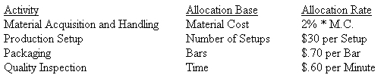
Activity measures for the two brands of soap follow:
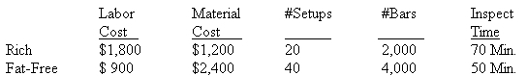
Part III (11) What is the total amount of overhead allocated to Fat-Free Soap if Durden uses ABC costing procedures? Your answer:___________ Please show your answer and the computation(s) supporting it below:
Part III (12) What is the total cost of 2,000 Bars of Rich Soap if Durden uses ABC costing procedures? Your answer:___________ Please show your answer and the computation(s) supporting it below:
Part III (13) What is the cost per bar of fat-free soap if Durden uses ABC costing? Your answer:___________ Please show your answer and the computation(s) supporting it below:
Part III (14) Hickory Home Company manufactures and sells two lines of furniture, case goods and upholstery. During the most recent accounting period, the Case Goods and Upholstery Divisions sold 15,000 and 2,000 units, respectively. The company's most recent financial statements are shown below:
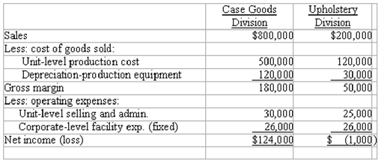
If unit sales for both divisions increased 10%, the company would report which of the following? Your answer:___________ Please show your answer and the computation(s) supporting it below:
A) |  |  | a 10% increase in total net income of the company
B) |  |  | A decline in profit for the Upholstery Division
C) |  |  | a $26,000 increase in net income for the Upholstery Division
D) |  |  | a net income for the Upholstery Division of $4,500
Part III (15) Scott Tools produces a variety of scissors and other cutting instruments at its Statesboro manufacturing plant. The plant is highly automated and uses an activity-based costing system to allocate overhead costs to its various product lines. The company expects to produce 12,000 total units during the current period. The costs and cost drivers associated with four activity cost pools are given below:
ACTIVITIES: | UNIT | BATCH | PRODUCT | FACILITY
 | LEVEL | LEVEL | LEVEL | LEVEL
Cost | $46,000 | ? | $10,000 | $60,000
Cost Driver | 2,500 labor hrs | 120 set ups | %of use | 12,000 units
Production of 1,000 units of a pipe-cutting tool required 250 labor hours, 18 setups, and consumed 19% of the product sustaining activities and resulted in an overhead allocation of $31,400. What amount of batch-level overhead costs was expected during the period? (Please, show the computations supporting your choice. Do not round your intermediate calculations. Round your final answer to the nearest whole number.)


